**Shop Nest Data Analysis**

## **Power BI Dashboard Documentation**

ShopNest stands as the leading department store in the e-commerce marketplaces in Portugal. Serving as a seamless link, it connects small businesses from various regions in Portugal to channels, streamlining the process with a single point of contact. Through the ShopNest Store, these merchants can showcase and sell their products, with the added convenience of direct shipment to customers facilitated by ShopNest logistics partners.

### **Introduction**

The **Shop Nest Data Analysis** dashboard provides a comprehensive overview of key metrics and trends related to Shop Nest’s operational and sales performance. This documentation serves as a guide to understanding the components, functionalities, and insights offered by the dashboard.

### **Dashboard Overview**

#### **Purpose and Objectives**

The **Shop Nest Data Analysis** dashboard is designed to provide a comprehensive view of the business's key performance metrics, enabling stakeholders to make informed decisions. This dashboard focuses on various aspects of the business, including sales, customer payments, product performance, and regional seller activity. The specific objectives of the dashboard are to:

* Monitor Sales Performance
* Evaluate Payment Trends and Preferences
* Analyse Customer Feedback and Ratings
* Assess Profitability Across Product Categories
* Track Seller Activity and Distribution

By integrating these analyses, the dashboard provides a holistic view of Shop Nest’s operational and sales performance, allowing for data-driven decision-making and strategic planning.

#### **Dashboard Design**

1. **Shop Nest Analysis**

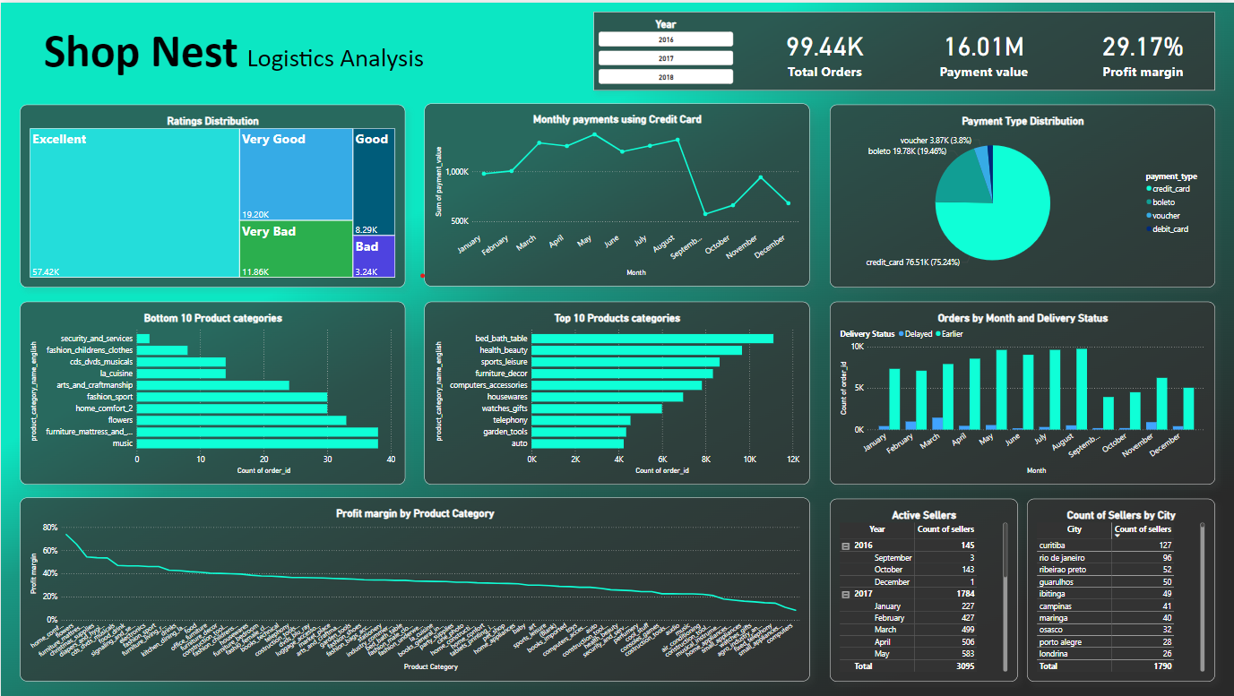

1. **Detailed Analysis of Late and On-time deliveries**

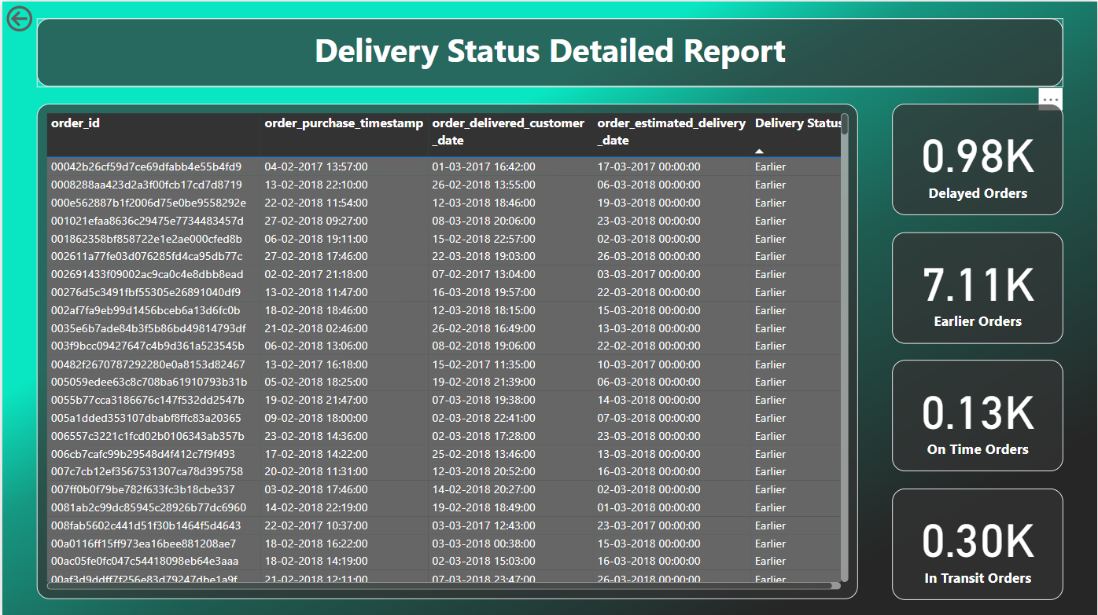

### **Analysis**

#### **Identify the rating distribution in the Shop_Nest dataset, showcasing ratings categorized as Excellent, Very Good, Good, Bad, and Very Bad, along with corresponding orders.**

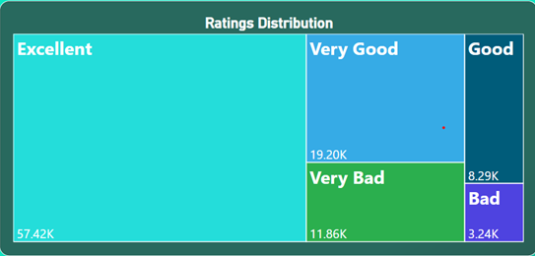

Distribution of reviews across orders

**Treemap Structure:**

* The treemap is a graphical representation where each category (or block) represents a specific rating level assigned to products by customers.
* The size of each block corresponds to the number of ratings within that category, providing a visual indication of the proportion of total ratings each category represents.
* The colour coding helps differentiate between the rating categories at a glance, making it easy to spot trends and patterns.

**Key Insights and Findings**

* **Dominance of 'Excellent' Ratings:**
  + The largest block on the treemap is the 'Excellent' category, which has a value of 57.42K. This indicates that a significant majority of customers rate the products very highly.
  + The large size of this block suggests that Shop Nest is successfully meeting or exceeding customer expectations in many aspects of its product offerings.
* **Distribution of Positive Ratings ('Very Good' and 'Good'):**
  + The 'Very Good' and 'Good' categories follow 'Excellent', with 19.20K and 8.29K ratings, respectively.
  + These blocks, while smaller than 'Excellent', still represent a substantial portion of the total ratings, highlighting a generally positive customer sentiment.
* **Presence of 'Very Bad' and 'Bad' Ratings:**
  + The 'Very Bad' category has 11.86K ratings, and the 'Bad' category has 3.24K ratings.
  + Although these categories are significantly smaller than the positive ratings, their presence indicates areas where customers have had negative experiences.
  + These ratings may point to specific issues with certain products or aspects of the customer experience that require attention.
* **Overall Positive Sentiment:**
  + Combining the 'Excellent', 'Very Good', and 'Good' ratings, we see that a vast majority of the ratings (approximately 85%+) are positive.
  + This overall positive sentiment is a strong indicator of customer satisfaction and loyalty.
* **Opportunities for Improvement:**
  + The existence of 'Very Bad' and 'Bad' ratings, while relatively small, highlights the need for continuous improvement in product quality, customer service, or other areas that may influence customer satisfaction.
  + Addressing the issues that lead to these negative ratings could potentially convert dissatisfied customers into loyal ones, further enhancing overall customer satisfaction and business performance.

**Actionable Recommendations**

* **Investigate Negative Ratings:** Conduct a detailed analysis of the products or categories that received 'Very Bad' and 'Bad' ratings to identify common issues and implement corrective actions.
* **Enhance Positive Feedback:** For products with 'Excellent' and 'Very Good' ratings, gather feedback on what customers appreciate and use these insights to further enhance the product features or customer experience.
* **Customer Feedback Loop:** Implement a feedback mechanism to continuously gather customer opinions and suggestions, which can help in refining products and services.

#### **What are the top 10 and bottom 10 most popular product categories in the ShopNest dataset? Please list them based on the number of orders.**

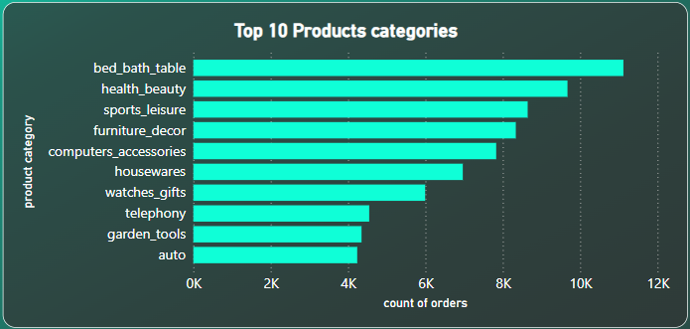

The **Top 10 Product Categories** bar chart provides an insightful look into the most popular product categories at Shop Nest, measured by the count of orders. The horizontal bars represent the number of orders associated with each product category, allowing for easy comparison between them.

**Key Insights and Findings**

* **Leading Product Categories:**
  + **Bed, Bath & Table** emerges as the top product category with the highest count of orders, indicating a strong customer preference for home essentials and decor-related items.
  + **Health & Beauty** follows closely, suggesting that personal care products are also highly sought after by customers.
* **Popular Leisure and Lifestyle Products:**
  + **Sports & Leisure** ranks third, highlighting the importance of lifestyle products among the customer base. This could be driven by trends in health, fitness, and outdoor activities.
  + **Furniture & Decor** is also a key category, further supporting the trend seen with the top category, where customers are investing in home improvement and furnishing.
* **Technology and Accessories Demand:**
  + **Computers & Accessories** has a notable count of orders, indicating a solid demand for technology products and related accessories. This could be reflective of the increasing reliance on technology for both work and leisure.
* **Diverse Product Interest:**
  + Categories such as **Housewares**, **Watches & Gifts**, **Telephony**, **Garden Tools**, and **Auto** round out the top 10, showcasing a diverse range of interests among customers.
  + The relatively close count of orders among these categories suggests that customers have varied needs and Shop Nest offers a wide range of products to meet those needs.
* **Competitive Landscape Among Categories:**
  + The narrow difference in order counts between some categories (e.g., **Furniture & Decor** vs. **Computers & Accessories**) indicates a competitive landscape where multiple product categories are performing well. This highlights the importance of maintaining a broad product mix to cater to different customer preferences.

**Actionable Recommendations**

* **Focus on Top Categories:**
  + Given the high performance of categories like **Bed, Bath & Table** and **Health & Beauty**, consider expanding these lines with new products or exclusive offerings to capitalize on customer interest.
* **Promote Leisure Products:**
  + The strong showing of **Sports & Leisure** suggests an opportunity for targeted marketing campaigns that could further boost sales in this category. Promotions or bundles related to fitness and outdoor activities could attract even more customers.
* **Leverage Technology Demand:**
  + Enhance the product offerings in **Computers & Accessories** by introducing the latest gadgets, accessories, or bundles to keep up with the tech-savvy customer base.
  + Consider partnerships with tech brands to offer exclusive deals or early access to new products.
* **Diverse Marketing Strategies:**
  + The diversity of the top 10 categories suggests that Shop Nest should employ a segmented marketing approach, tailoring promotions and communication strategies to different customer groups based on their interests (e.g., home improvement enthusiasts, tech lovers, fitness buffs).
* **Monitor Emerging Trends:**
  + Continuously monitor sales data to identify any shifts in customer preferences or emerging trends within these categories. This will allow Shop Nest to stay ahead of the curve and adjust product offerings or marketing strategies accordingly.

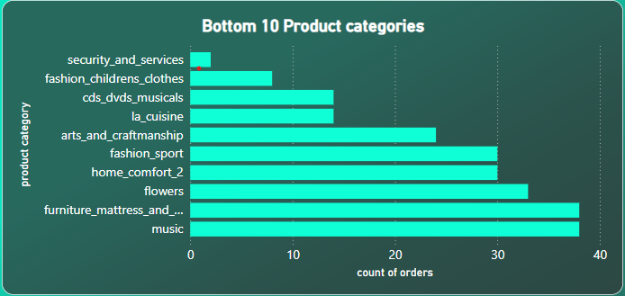

The **Bottom 10 Product Categories** bar chart highlights the product categories with the lowest count of orders at Shop Nest. This visualization is essential for identifying areas where products are underperforming, potentially indicating a lack of customer interest, ineffective marketing, or other factors that may require attention.

**Key Insights and Findings**

* **Low Demand in Security and Services:**
  + **Security and Services** is the category with the lowest number of orders. This could suggest that these services are not in high demand among Shop Nest’s customers, or it might reflect a niche market with limited appeal.
* **Underperformance in Children’s Fashion and Media:**
  + **Fashion Children’s Clothes** and **CDs, DVDs, Musicals** are also among the lowest-performing categories.
  + The low order count in **Children’s Fashion** could be due to a highly competitive market or a mismatch between the products offered and customer preferences.
  + The declining popularity of physical media formats such as CDs and DVDs could explain the poor performance in the **CDs, DVDs, Musicals** category.
* **Niche or Specialized Categories:**
  + Categories such as **La Cuisine** (likely related to cooking products), **Arts and Craftsmanship**, and **Fashion Sport** have low order counts, indicating they may cater to niche markets.
  + These categories may require targeted marketing or product adjustments to better align with customer needs and preferences.
* **Moderately Performing Home and Lifestyle Products:**
  + **Home Comfort**, **Flowers**, **Furniture, Mattress, and Bedding**, and **Music** round out the bottom 10 but with relatively higher order counts compared to the other categories in this list.
  + These categories, while not leading in orders, still have a moderate level of interest that might be increased with strategic marketing or product enhancements.
* **Potential for Improvement:**
  + The fact that categories such as **Furniture, Mattress, and Bedding** and **Music** are near the bottom suggests there might be untapped potential, possibly due to insufficient exposure or lack of variety within these categories.
  + **Flowers** might reflect a seasonal or occasion-based purchasing pattern, where orders spike during specific times of the year but remain low otherwise.

**Actionable Recommendations**

* **Reevaluate Product Offerings:**
  + For categories like **Security and Services** and **Children’s Fashion**, consider whether these products meet the needs and preferences of your customer base. It might be necessary to refresh the product lineup or adjust pricing strategies to increase demand.
* **Targeted Marketing Campaigns:**
  + Implement targeted marketing campaigns for niche categories such as **La Cuisine**, **Arts and Craftsmanship**, and **Fashion Sport** to raise awareness and drive customer engagement.
  + Utilize customer data to tailor promotions and content that resonate with specific customer segments who may have an interest in these products.
* **Enhance Product Appeal:**
  + For underperforming categories like **CDs, DVDs, Musicals**, consider diversifying the product range to include more modern formats such as digital downloads or streaming services, if applicable.
  + For **Furniture, Mattress, and Bedding** and **Home Comfort**, focus on showcasing the quality, design, and comfort features in promotional materials to attract more customers.
* **Seasonal Promotions:**
  + For **Flowers** and similar categories, consider implementing seasonal promotions or special occasion campaigns (e.g., Valentine’s Day, Mother’s Day) to boost orders during peak periods.
* **Product Discontinuation or Adjustment:**
  + If certain categories consistently underperform despite efforts to boost sales, it may be worth considering discontinuing these products and reallocating resources to more successful areas.

#### **List the total number of active sellers by yearly and monthly.**

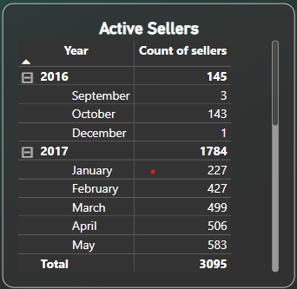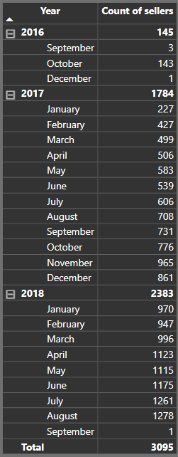

This table provides a detailed breakdown of the **Count of Sellers** by month and year from 2016 to 2018. The table allows for an analysis of the growth and trends in the number of sellers on the Shop Nest platform over time.

**Key Insights and Findings**

* **Initial Seller Base in 2016:**
  + In 2016, the platform had a modest start with a total of 145 sellers. The majority of these sellers joined in October, indicating a possible launch or significant event during this period that attracted a large number of sellers.
* **Significant Growth in 2017:**
  + The number of sellers increased dramatically in 2017, totaling 1,784, which is more than ten times the count from the previous year.
  + The monthly data shows a steady increase throughout the year, with notable jumps in April, August, and particularly in November, which could suggest successful recruitment drives, marketing campaigns, or seasonal spikes.
* **Continued Expansion in 2018:**
  + Growth continued in 2018, with the total number of sellers reaching 2,383 by the end of the year.
  + The monthly increase in 2018 is consistent, with the highest growth observed from April to August. This period saw the number of sellers rise from 1,123 in April to 1,278 in August, suggesting that the platform continued to attract new sellers at an accelerating rate.
* **Total Growth Over the Period:**
  + From 2016 to 2018, the platform experienced substantial growth, with the total count of sellers reaching 3,095 by September 2018.
  + The data reflects the platform’s increasing popularity and the successful onboarding of sellers over these three years.

**Actionable Recommendations**

* **Analyse Key Growth Periods:**
  + Investigate the reasons behind the significant spikes in seller count during specific months, particularly in late 2017 and mid-2018. Understanding these factors can help replicate this success in future recruitment efforts.
* **Support Seller Onboarding:**
  + As the number of sellers continues to grow, it’s important to ensure that the onboarding process is smooth and that new sellers are adequately supported to succeed on the platform. Consider implementing additional resources or automated processes to handle the influx of new sellers.
* **Monitor Seasonal Trends:**
  + The data indicates potential seasonal trends in seller growth. Monitoring these trends could help in planning marketing campaigns or onboarding initiatives during peak periods to maximize seller acquisition.
* **Retention Strategies:**
  + Focus on seller retention strategies to maintain and grow the seller base. This could include providing sellers with tools for success, regular training, or incentives to remain active on the platform.

#### **Which payment methods are most commonly used by ShopNest customers.**

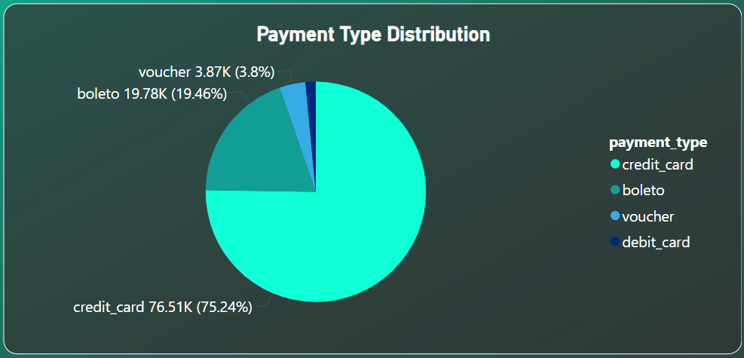

The pie chart depicting the **Payment Type Distribution** provides a visual breakdown of the most commonly used payment methods by customers at Shop Nest. The chart allows for an easy comparison of the popularity of different payment methods based on the count of orders associated with each.

**Key Insights and Findings**

* **Dominance of Credit Card Payments:**
  + **Credit Card** payments account for the overwhelming majority, with **76,505 orders**. This method represents the largest portion of the pie chart, indicating that the vast majority of customers prefer using credit cards for their purchases.
  + The dominance of credit cards could be attributed to the convenience, security, and potential rewards or benefits associated with credit card use.
* **Significant Use of Boleto:**
  + The **Boleto** payment method is the second most popular, with **19,784 orders**. While significantly less than credit card payments, Boleto still represents a substantial portion of the total orders.
  + Boleto is a common payment method in certain regions, especially in Brazil, where it allows customers to pay using a bank slip either online or in person at various locations.
* **Limited Use of Vouchers and Debit Cards:**
  + **Vouchers** account for **3,866 orders**, making it the third most common payment method. Vouchers might be used for gift purchases or promotional purposes, which explains their lower frequency.
  + **Debit Cards** are the least commonly used, with only **1,528 orders**. This lower usage could be due to customer preferences for credit over debit, possibly due to the additional benefits and protections offered by credit cards.
* **Customer Payment Preferences:**
  + The distribution of payment types reflects customer preferences, where convenience, security, and possibly rewards influence the choice of payment method.
  + The significant difference between credit card use and other methods suggests that most customers prioritize ease of payment and possibly the ability to finance purchases through credit.

**Actionable Recommendations**

* **Leverage Credit Card Popularity:**
  + Given the high preference for credit card payments, consider partnerships with credit card companies to offer exclusive deals, rewards, or cashback offers to incentivize even more purchases through this method.
* **Promote Boleto and Voucher Payments:**
  + Since Boleto is the second most popular method, ensure that it remains a well-supported and promoted option, particularly in regions where it is most commonly used.
  + Vouchers could be promoted through marketing campaigns, especially during holidays or special sales events, to increase their usage and appeal.
* **Encourage Debit Card Use:**
  + Although debit card usage is low, there might be potential to encourage its use by offering incentives or discounts for debit card transactions. This could appeal to customers who prefer to avoid credit card debt or manage their finances more closely.
* **Monitor Trends in Payment Methods:**
  + Continuously monitor the trends in payment method usage to detect any shifts in customer preferences. This data can help Shop Nest adapt its payment options and marketing strategies to better align with customer needs.
* **Customer Education and Payment Options:**
  + Educate customers on the benefits of using different payment methods, including the safety, ease, and potential rewards. This could help in diversifying payment method usage and improving customer satisfaction.

#### **Identify the product category. wise profit margin using the formula**

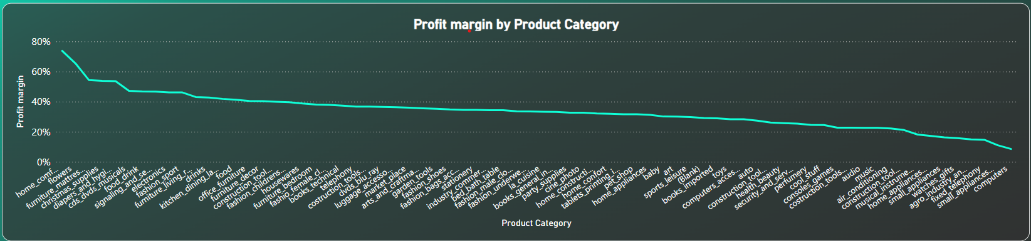

This line chart provides the Profit Margin for various product categories sold on the Shop Nest platform. The profit margin is a key metric that indicates the percentage of revenue that remains after deducting the cost of goods sold (COGS), reflecting the profitability of each product category.

**Key Insights and Findings**

* **High-Profit Margin Categories:**
  + The top product category in terms of profit margin is **"home_comfort_2"**, with a profit margin of **73.74%**. This indicates a highly profitable category, where a significant portion of the revenue remains as profit after covering the costs.
  + Other high-profit categories include **"flowers"** (65.39%), **"furniture_mattress_and_upholstery"** (54.36%), and **"christmas_supplies"** (53.77%). These categories are likely driven by niche markets or seasonal demand, allowing for higher markups.
* **Moderate-Profit Margin Categories:**
  + Categories such as **"electronics"** (46.14%), **"fashion_sport"** (46.10%), and **"furniture_living_room"** (43.03%) have moderate profit margins, ranging between 40% and 50%.
  + These categories represent a balance between volume and profitability, likely benefiting from strong sales volumes while maintaining reasonable margins.
* **Low-Profit Margin Categories:**
  + The product categories with the lowest profit margins include **"small_appliances_home_oven_and_coffee"** (10.99%) and **"computers"** (8.50%). These categories might be more competitive, with lower margins driven by market price pressures or higher costs.
  + **"watches_gifts"** and **"agro_industry_and_commerce"** also have low-profit margins, suggesting that these categories may rely on volume sales or have thinner margins due to high COGS.
* **Strategic Categories:**
  + High-profit categories like **"home_comfort_2"** and **"flowers"** are critical for maximizing profitability. Strategies should be developed to promote these categories or expand their offerings.
  + For lower-margin categories, such as **"computers"** and **"small_appliances"**, it might be beneficial to explore cost-saving measures, negotiate better terms with suppliers, or increase sales volumes to enhance profitability.

**Actionable Recommendations**

* **Focus on High-Margin Categories:**
  + Invest in marketing and sales efforts for high-margin categories such as **"home_comfort_2"** and **"furniture_mattress_and_upholstery"**. Promoting these categories more aggressively could lead to significant increases in overall profitability.
* **Optimize Low-Margin Categories:**
  + For low-margin categories, explore opportunities to reduce costs, negotiate better supplier contracts, or streamline operations. This could help improve the overall profitability of these categories without sacrificing sales volume.
* **Category-Specific Promotions:**
  + Implement targeted promotions and discounts for high-margin categories during peak seasons or special events to boost sales further and capitalize on their profitability.
  + For categories with lower margins, consider bundling products or offering upsells to increase the average transaction value.
* **Monitor Competitive Categories:**
  + Keep a close eye on competitive categories like **"computers"** and **"small_appliances"**. Regularly review pricing strategies, and consider focusing on unique selling propositions (USPs) to differentiate these products and maintain a competitive edge.

#### **Determine the monthly payments made by customers using credit cards.**

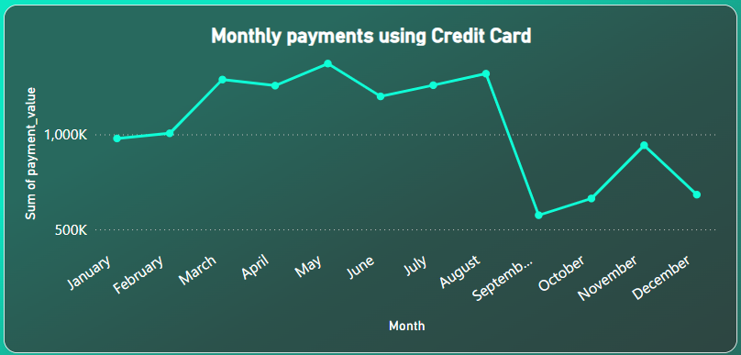

The visual provides a breakdown of monthly payments made using credit cards, with values converted into thousands (K). This analysis highlights key patterns and trends in credit card usage throughout the year.

**Key Insights and Findings**

* **Peak Payment Periods:**
  + **May** stands out as the month with the highest total payments, reaching **1,372.60K**. This suggests a peak period in consumer spending, potentially driven by seasonal factors like mid-year sales, Mother's Day, or other promotional events.
  + **August** and **March** also show high payment levels, with **1,319.24K** and **1,288.26K** respectively. These months likely benefit from summer spending and early-year promotions, indicating robust consumer activity during these periods.
* **Significant Dip in September:**
  + A notable dip occurs in **September**, with payments dropping to **574.74K**. This is a significant decrease compared to the surrounding months and suggests a seasonal lull in spending. Factors like the end of summer vacations, back-to-school expenses, or consumer saving behaviours might contribute to this downturn.
  + After September, payments gradually recover in **October** (**781.96K**) and significantly increase in **November** (**1,174.64K**), likely due to early holiday shopping.
* **Consistent Payment Levels in the First Half of the Year:**
  + The first half of the year (January through June) exhibits relatively consistent payment levels, ranging from **1,023.41K** to **1,372.60K**. This stability indicates a steady pattern of credit card usage, with slight increases potentially linked to specific marketing campaigns or seasonal events.
* **Year-End Surge in November and December:**
  + **November** and **December** payments reflect the expected year-end surge, with totals of **1,174.64K** and **1,251.75K** respectively. This surge aligns with the holiday season, when consumer spending typically increases due to Black Friday, Cyber Monday, and Christmas shopping.

**Actionable Recommendations**

* **Leverage Peak Months for Promotions:**
  + Capitalize on the high payment months of **May**, **August**, and **March** by launching targeted marketing campaigns or sales events. Maximizing consumer engagement during these periods can further boost revenue and enhance customer retention.
* **Address the September Decline:**
  + Investigate the causes of the sharp decline in September. Consider implementing strategies such as back-to-school promotions, end-of-summer sales, or loyalty rewards to stimulate spending during this slower period.
* **Prepare for the Year-End Rush:**
  + Ensure adequate inventory and staffing in preparation for the November and December surge. Strategic promotions and early holiday deals can help capture more of the year-end spending and increase market share.
* **Maintain Consistency with Seasonal Promotions:**
  + Continue to offer consistent promotions during the first half of the year to maintain steady payment levels. Focus on events that drive spending, such as Valentine's Day, Easter, and mid-year sales, to keep consumer interest high.
* **Monitor Monthly Payment Trends:**
  + Regularly analyse monthly payment trends to stay ahead of shifts in consumer behaviour. This proactive approach will allow for timely adjustments in marketing strategies, ensuring that Shop Nest remains competitive and responsive to market changes.

#### **Identify sellers categorized by city, excluding cities starting with the letters S and B.**

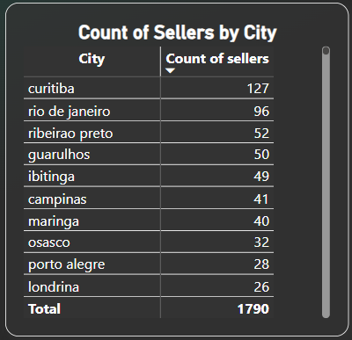

**Key Insights and findings:**

* **Top Cities by Seller Count:**
  + **Curitiba** stands out as the city with the highest number of sellers (127 sellers), followed by **Rio de Janeiro** (96 sellers).
  + The top 5 cities are Curitiba, Rio de Janeiro, Ribeirao Preto (52 sellers), Guarulhos (50 sellers), and Ibitinga (49 sellers).
* **Seller Distribution:**
  + A significant concentration of sellers is found in major urban centres, particularly in the Southeast and Southern regions of Brazil.
  + The distribution quickly tapers off, with the majority of cities having a relatively small number of sellers (1-5 sellers). This suggests that most of the sellers are concentrated in a few key cities.
* **Mid-Tier Cities:**
  + Cities like **Campinas**, **Maringa**, and **Osasco** have a moderate number of sellers, ranging from 30 to 50. These cities might be potential growth areas.
  + There is a noticeable drop in the number of sellers as we move to cities with less than 20 sellers, showing a steep decline after the top 10 cities.
* **Long Tail:**
  + There is a long tail of cities with very few sellers (1-2 sellers). These cities, while numerous, contribute less individually to the overall seller base but could present untapped market opportunities.
* **Geographical Spread:**
  + There is a wide geographical spread of sellers, but the highest concentrations are in urban and suburban areas, especially in São Paulo, Rio de Janeiro, and Paraná states.

**Actionable Recommendations:**

* **Focus on Top Cities:**
  + **Curitiba** and **Rio de Janeiro** should be prioritized for targeted marketing efforts and seller engagement programs, as they have the highest concentration of sellers.
  + Consider strengthening support and infrastructure in these cities to maintain and grow seller participation.
* **Expand in Mid-Tier Cities:**
  + Cities like **Campinas**, **Maringa**, and **Osasco** present opportunities for growth. Initiatives could be designed to increase the seller base in these areas, such as offering incentives for new sellers or enhancing the visibility of existing sellers.
* **Explore Opportunities in Low-Seller Cities:**
  + Although cities with only 1-5 sellers have a lower immediate impact, they represent potential growth markets. Focused efforts to identify and support sellers in these areas could unlock new markets.
  + Conduct research to understand the barriers to seller growth in these regions and address them (e.g., logistics, lack of awareness, etc.).
* **Regional Marketing Strategy:**
  + Develop region-specific marketing strategies that cater to the unique needs of sellers in different regions. For instance, the Southeast region, with its higher seller density, might benefit from more competitive strategies, whereas the North and Northeast might require awareness-building efforts.
* **Strengthen Infrastructure:**
  + For cities with a higher seller count, consider enhancing logistical support and reducing barriers to entry for new sellers. This could include easier onboarding processes, better access to customer service, and localized resources.
* **Identify Potential Clusters:**
  + Consider exploring the creation of seller clusters or communities in regions where seller numbers are growing. These clusters can provide peer support, increase seller engagement, and foster a competitive yet collaborative environment.

#### **Create a dynamic visual that compares the number of delayed orders to the number of orders received earlier for each month. Utilize the drill through the cross-report feature to provide a detailed analysis of late and on-time deliveries.**

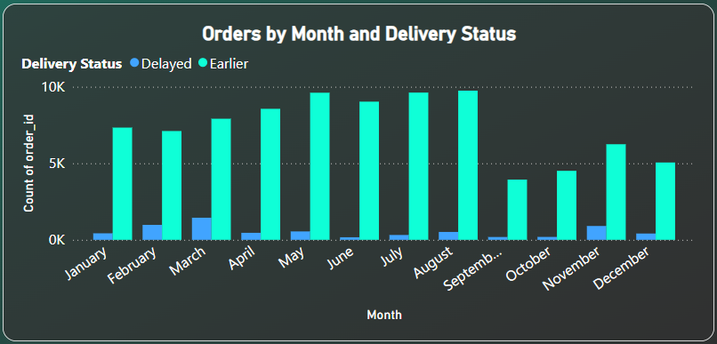

**Key Insights and findings:**

* **Overall Trends:**
  + **Earlier Deliveries:** In general, the number of orders delivered earlier significantly exceeds those delivered delayed each month. This trend is consistent throughout the year.
  + **Delayed Deliveries:** The number of delayed deliveries is notably lower compared to early deliveries each month.
* **Monthly Breakdown:**
  + **Peaks in Earlier Deliveries:** The number of orders delivered earlier peaks in months with higher counts, such as January (7332), February (7107), and May (9610). This indicates that during these months, there were more orders delivered earlier.
  + **Peaks in Delayed Deliveries:** Delayed deliveries peak in March (1444) and November (904). While still lower than early deliveries, these months experience relatively higher counts of delays.
* **Low Points:**
  + **Fewest Earlier Deliveries:** The months with the fewest number of earlier deliveries are June (9027) and August (9745), but these figures are still quite substantial.
  + **Fewest Delayed Deliveries:** The months with the fewest number of delayed deliveries are June (166) and September (183), highlighting a relatively better delivery performance in these months.
* **Seasonal Variations:**
  + There doesn’t seem to be a clear seasonal pattern, as the data shows fluctuations in both earlier and delayed deliveries without a strong correlation to specific times of the year.

**Actionable Recommendations:**

* **Enhance Efficiency in Peak Months:**
  + **Focus on Peak Delivery Months:** Since months like January, February, May, and August see higher numbers of orders delivered earlier, these months may be critical for optimizing operations. Consider ramping up resources or streamlining processes during these peak periods to maintain or improve performance.
* **Address Delays in High-Delay Months:**
  + **Investigate Causes of Delays:** For months with higher delayed orders, such as March and November, conduct a thorough analysis to identify root causes. Are there specific logistical or operational issues contributing to delays? Addressing these causes can help reduce the number of delayed deliveries in the future.
* **Implement Proactive Strategies:**
  + **Proactive Planning:** Develop proactive strategies for managing peak periods and potential delays. This could involve increasing staffing, optimizing supply chain logistics, or using predictive analytics to anticipate and address potential issues before they impact delivery times.
* **Improve Communication:**
  + **Customer Communication:** Enhance communication with customers during periods of high order volumes or known delays. Providing timely updates and estimated delivery times can help manage customer expectations and improve satisfaction.
* **Monitor and Adjust:**
  + **Regular Monitoring:** Continuously monitor delivery performance metrics to quickly identify and respond to any emerging trends or issues. Adjust strategies and operations as needed based on real-time data and performance insights.
* **Leverage Successful Practices:**
  + **Analyse Success Factors:** Look at the practices and processes in place during months with high numbers of early deliveries. Identify what is working well and consider implementing similar practices during months with higher delays.

In order to improve delivery performance analysis, a drill-through report function has been added. This enables users to examine particular data points in greater detail straight from the clustered column chart. This report, which can be filtered by month and other chart parameters, provides information on the delivery status of the orders, the total number of orders delayed, delivered early, on time, and in transit orders.

